**Ariel Barrionuevo & Lorena Gasse**

**Three days of Tango**

**Six Lessons**

**Two Practilongas & one Milonga**

**Performances by the Artists**

**Beautiful Space**

**Private Lessons Available**

**Sept. 15 – 17, 2016 (Thurs. – Sat.)**

**Cannon Studios**

**360 33rd Ave SW, Suite G**

**Cedar Rapids, IA 52402**

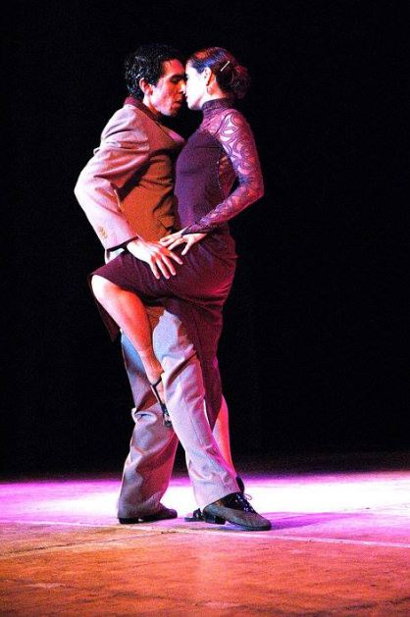

**Iowa Tango Presents:**

**Ariel Barrionuevo & Lorena Gasse**

**Tango Workshop**

**Sept. 15 – 17, 2016**

**Ariel Barrionuevo & Lorena Gasse have been dancing together for the last fifteen years. They are the directors of their dance company in Argentina, and are acclaimed instructors performing and teaching world-wide. They are known within the tango community in the USA for their profound sense of joy that shows up whether they dance tango, milonga, vals, canyengue or folkloric dances. Their last trip to USA was during their 2015 tour, which was preceded by performances in Rome and Carrara, at the invitation of the Italian government. This year will be their 11th visit to USA with participation at the Vermont tango festival.**

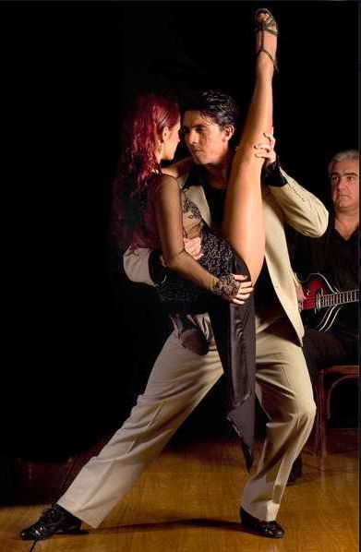

**Early Bird Registration form**

***Ariel Barrionuevo & Lorena Gasse***

***Argentine Tango Workshop - Sept.15th-17, 2016***

**Name………………………………………………………….**

**Email/phone………………………………………………… Lead…Follow…College, if Student……………………..**

**Thursday Sept. 15th**

**Musicality 7:00-8:30 pm- all level**

**Practilonga; 8:30-11:00 pm**

**Friday Sept. 16th**

**All within the giros 6:30-8:00 pm – all levels**

**Improvisation 8:10- 9:40 pm- Intermediate**

**Practilonga 9:45-11:45 pm**

**Saturday Sept. 17th**

**Leg wraps 1:30 – 3:00 pm- Intermediate**

**Milonga Lisa & traspié 3:15- 4:45 pm- Intermediate**

**Fun w/ chacarera 7:45- 8:15 pm- all levels**

**Milonga with performance 8:30pm- 12:00 am**

**Early Bird payment due by Sept. 1st**

**Full pass (6-classes + 2 Practilonga & one Milonga) $105/$75 student.**

**After Sept. 1st, full pass $120/$90 student**

**One class $25/$15 student , two or more classes $20/each (10 student)**

**Practilonga (Thurs. and Fri.) $7**

**Saturday Milonga $10**